International Institutions and the Rise of European Nationalism
Following World War I and II, civilians and elites alike across the European continent had experienced their fair share of the negative implications which resulted from international conflict the likes of which planet Earth had never seen. In the wake of this unprecedented global power struggle, politicians were tasked with finding a solution to a question so complex that it still remains debated to this day. The question: what measures can be taken to ensure continued peace and promote economic prosperity for all nations? Their response to this puzzling challenge is today referred to as liberalism among those who study international relations and economic theory. In implementing this ideal, experts argued that as countries become more economically independent of each other, they are also far less likely to engage in conflict due to the negative consequences that the country lashing out will inevitably experience (even if losses are minimal in terms of loss of human life). This stance is the root of the approach a majority of nations take to this day on virtually every continent spanning the globe. While the implementation of the idea has failed to gain united global traction, the European Union represents the most successful example of what can be accomplished when the concept is integrated in the form of a regional bloc. Observing the Brexit referendum, French election, and even the recent US election placing Donald Trump in office, a theme of increasing nationalism and the revival of populist leadership has become clearly evident. These ideals work in direct opposition to liberal theory, as nations supporting this trend have shifted towards protectionist policies that they feel benefit domestic interests despite the failure of most citizens to realize the proven losses associated that rise commodity prices, and therefore, counteract any perceived wage increase for laborers. In addition, the fear of losing sovereignty in decision making is cited as a large factor for the nationalist trend we’ve seen in Europe. While this argument is valid, one must also consider the benefits of stability that come along with a merged market sharing a single currency. As I will explain in further detail later on, the formerly discussed factors coupled with historical and cultural perceptions separate nations hold have massive implications. This applies not only on who they trade with, but also if they decide their participation in regional blocs is worth the loss of an extent of freedom in order to gain greater economic prosperity. Therefore, I will seek to explain the pros and cons these international institutions and the effect that nationalist movements will have on the future prospects of us moving towards a more integrated and globalized world through the lens of Brexit referendum. As you will see, the argument I pose is very in favor of the idea that the benefits created by modernization, integration, and the acceptance of a globalized world far outweigh the negatives associated with reverting to the reclusive nature produced by nationalism.
Old Traditions Die Hard in the Formerly Hegemonic Powerhouse
Historically speaking, the United Kingdoms is one of the most storied and prevalent actors on the international stage throughout much of recorded human existence. Great Britain itself has held colonies through both direct and indirect influence on nearly every continent at certain points in its’ past. This stands especially true when discussing the modern history era, as it slowly has grown from a territory under the control of the Roman Empire, to an empire of its own accord exceeding even the Romans (or anyone else for that matter). By 1938, the superpower had acquired not only 13.01 million square miles of land (22% of Earth’s terrestrial space), but also ruled over 20% of the existing worldwide population of the time, coming out to roughly 458 people (Rogers 2011). They were in a league of their own, as the next closest empire to have a reach that large and diverse lagged behind in both categories constituting barely over a two-thirds of what was achieved by the British (Rogers 2011). Taking all this into consideration, the assumption that a great sense of nationalism and an appreciation for sovereignty within its origin territory still exists less than a hundred years later is far from purely a speculative hypothesis. In addition, it’s worth noting that while the empire was massive, the system of colonization tended to be focused on the extraction of resources or other factors that would benefit mainland Britain. This contrasts the Romans who encouraged a method of integration into their culture as a means of bettering the quality of life for those who didn’t reside in its origin state. This is important due to the main reasons cited by those who voted to leave, which are: immigration, economic sovereignty, and perceived national identity (Clarke, Goodwin, Whiteley 2016).
The UK’s Cultural History Still Reflects Policy to this Day
The three factors in the former paragraph show us the historical values that are still relevant to the UK and have influenced their policymaking to this day. As a nation with such a strong sense of pride and identity, the rise of populism has spawned more easily. Problems associated with low-skilled immigrants that have rushed to the country in search of jobs have caused concern with locals who feel they will suffer from lower wages as the supply of labor increases. Especially among the lesser educated British citizens, a stance mirroring the formerly mentioned traditional values have sought to protect the wellbeing of the motherland and their own interest at all costs, believing a break from the EU will slow this immigration wave. In addition, those who support the break argue that countries with struggling economies like Greece have caused major issues for the EU. Instead of continuing to fund required loans to attempt prop up Greece’s disastrous situation, economic sovereignty would allow the UK to instead invest in infrastructure that would spur long-term growth for themselves. In summary, the protectionist policies on the rise in the UK continue to be debated, as many find these populist practices to be regressive in the modernized world of today. Despite this, there is still a large portion of people who stick to the traditional ideals that once made the islands, specifically Great Britain, into one of the great powers the world has ever seen.
Populism: Responding to a Changing United Kingdoms
The ideal of populism has been rapidly spreading throughout the Western world, bringing a radical regime shift that has resulted in increased nationalist sentiment in many countries. While looking out for the needs of the common man can be considered good in certain cases, it can also lead to discrimination in others. It also fails to account for the fact that the common man, usually less educated than those with higher status, tend to suffer from lower education than elites. Evidence of this is easily observed when looking at a map of the regional breakdown between voting districts. In highly populated urban areas (where a consensus of social experts agree that diversity of ideas and higher education degrees are more common per capita) we see a clear trend to stay in the EU opposed to rural regions (Becker, Fetzer, Novy 2017). This means that while they think they are looking out for the best interest of their country and themselves, they may actually end up supporting a policy that in actuality isn’t positive for either.
This is not true only in United Kingdoms, but by Marine Le Pen in the recent French election, Italy’s own populist parties that is gaining traction by forcing the resignation of Matteo Renzi, and even across the Atlantic with the election of Donald Trump as president in other countries. Nigel Farage, British politician, broadcaster and analyst, is the person associated most with the decision to split from mainland Europe. For over a decade he has stood as a Eurosceptic fighting for his goal of an independent UK. In addition, many cite him as the reason for the Western world’s acceptance of such extreme nationalism and populism that has seem to arisen nearly out of nowhere. According to a Times Magazine article, Farage has even got hands-on within the Trump campaign, “[spending] weeks in the U.S. stumping for Trump” (Shuster 2016). Not only has he rooted his populist ideals, the same article even noted his activity in giving speeches and lectures in multiple other developed nations to gain further traction (Shuster 2016). This could very well have been a driving factor in Marine Le Pen winning the recent French election and Italy’s populist parties rapid traction gained that forced the resignation of former Prime Minister Matteo Renzi. Due to this, upcoming elections in other democratic European nations in coming years will have huge implications of future international political and economic culture. If Farage succeeds in making this “New World Order” and destroying the one of old, it’s very possible the strides in economic growth and living standards associated with specialization and interconnectivity the world has experienced could very well be demolished entirely.
In regard to the Brexit situation, when those who voted to leave were polled on what their main reasons for leaving the EU were, immigration was a recurring theme. The UK has historically been a nation who has primarily not had large swaths of diversity, even relative to the rest of homogeneous Europe and especially compared to areas like the United States or the Middle East (Fearon 2013). Historically, while divided as separate countries during certain time periods, the UK has failed to even association themselves to other Europeans (especially those of the Eastern post-communist nations). Xenophobia, the irrational dislike of people from another nation or region, has therefore been strongly entrenched into the mind of those who voted to leave as the rural individuals suffer from a lack of cosmopolitanism view that are associated with exposure to urbanized regions. As social scientist Alexander Betts describes on TEDTalks, in his experience living in the UK his entire life, he claims to only have visited any of the regions who voted to leave a grand total of four times in his life (Betts 2016). This shows just how divided citizens can be who perceive themselves united, even those of a nation many consider homogeneous in nature, without even realizing the actual situation.
The EU: Immigration and Sovereignty Loss
The main cause for this irrational nationalism, populism, and xenophobia lately comes chiefly from the influx of Syrian migrants seeking refuge from the warring nation they once called home. With no place to go, they have either flee to neighboring nations that have become overwhelmed or seek asylum in the EU. This has created a huge debate among whether everyone should be required to share the burden of the unprecedented inflow. The UK, already limited in geographical size, was one of the countries opposed to this as their more well-off citizens despised the crime they assume will be associated while lower income citizens fear their jobs being taken and wages lowered as a result of labor supply increases. While rejection of post-communist Eastern European countries also play a role, the condition and perceived crime rate and labor implications associated with asylum-seeking Syrian refugees maintains the lead role.
The geographic isolation from the rest of the continent is unique to mainland Europe, and has led to a larger relative portion of people identifying themselves first and foremost as solely UK citizens. This has caused a sentiment that puts little emphasis on the pride of being a European in addition to a UK citizen, and explains why they would reject the refugee policy imposed upon them by the EU. Therefore, a feeling of lost sovereignty coupled with a historic cultural sentiment of being distinct from the rest of Europe has created the outrage that played a role in the Brexit decision. While the analysis I have presented so far is primarily from a social and historical standpoint, the economic implications of the decision have even more far-reaching implications. That being said, now that a foundation of why voters decided to leave has been laid, I will now delve further into why such international institutions are beneficial.
International Institutions Promote Economic Prosperity
Free trade theory has changed the landscape of our planet rapidly, creating growth on a scale never before seen in history. The driver of this is specialization of labor and comparative advantage, which allow each country to produce a certain good or service for a much lower price, and therefore, trade it for a much lower price to other nations. This means everyone wins because everyone country can get the goods and services they want for a cheaper price opposed to if they produced everything themselves. Production without barriers such as tariffs creates greater efficiency in addition, as otherwise producers would have to charge higher prices on goods exported due to the fee added on. Having a labor force large enough to meet demands of consumers is also vital, which is where international institutions play such a great role in the development of wealth and the prosperity of countries.
The EU modeled itself after the Unites States in many ways, using the idea of a single market to create a larger market of consumers for each country thus spurring growth without having to hop over customs duties tariffs, or any other hindering barrier. Although the United Kingdoms is unique compared to most country considering its use of the Pound instead of euro as currency, it still benefitted from the labor movement and lack of barriers. Although the UK joined due to its support for the single market idea and regional policy initially, their opinion towards the union has become “increasingly lukewarm” in recent years (Becker, Fetzer, Novy 2017). Nations such as Greece who suffered from the 2008 financial crisis are a reason many criticize the EU lately as being a bad idea despite the continued strong value of the euro on the foreign exchange market. In addition, Greece falsifying their financial portfolio led to even more outrage as loans continue to be poured into the country’s development with little progress seen. With a history of wealth as a sovereign nation (specifically Britain), many felt the support of Greece was a cost too much to bear for the benefits gained from membership and that they would be able to do just fine on their own.
Splitting from the EU was no consensus among the entire nation though, as the vote was extremely close and almost no one initially expected the referendum to actually pass. In cities, (which are considered centers of education due to the diversity of demographics and new ideas are stimulated through the sharing of different perspectives) education rates are higher vs. rural communities (Becker, Fetzer, Novy 2017). In turn, this means that individuals are likely more informed and thus (theoretically speaking) more likely to know what is best for their country. Irrational nationalism steps in here when a map of regional breakdown of voting is observed, as you notice more urbanized areas tended to vote to remain when observing regional voting breakdowns presented by the visual on page 11 (University of Oxford 2017). This is likely correlated with education rates and per capita income as the benefits associated with availability to a larger market not only helps producers reach a larger market and profit more, but also creates more consumption that will lead to increased spending on public spending that can be used to invest in long-term infrastructure projects that will create more jobs for even the common man.

Concluding Remarks
While the possibilities of what will come from Brexit depends greatly on if it is a hard or soft break, it undoubtedly will have a massive impact on how the rest of the world perceives often radical populist political agendas, the effectiveness of regional trade blocs and what the makeup of the economy of the UK will look like. Most likely if there’s a hard Brexit, the UK’s economy will suffer greatly while the EU will also lose one of its largest economies in its system along with credibility as an institution. As the world watches on, we may be witnessing history as many of the most influential countries in the world continue to make shifts towards nationalist protectionism measures and away from free trade. Only time will tell, but the fate of the European Union is certainly anything but certain until negotiations cease and a final verdict is released.

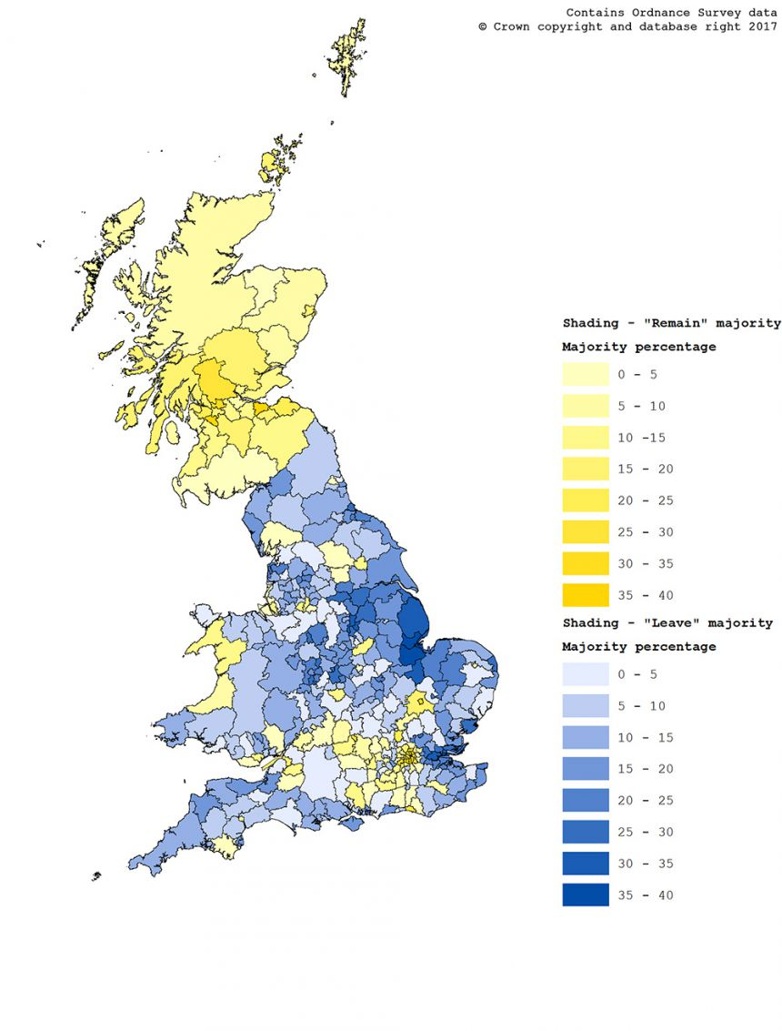
References
Wheeler, Alex Hunt & Brian. “Brexit: All you need to know about the UK leaving the EU.” BBC News, BBC, 26 Feb. 2018, www.bbc.com/news/uk-politics-32810887.

Rogers, Abby. “The 10 Greatest Empires In The History Of The World.” Business Insider, Business Insider, 9 Nov. 2011, www.businessinsider.com/the-10-greatest-empires-in- history-2011-9#2-the-mongol-empire-was-the-largest-contiguous-empire-the-world- has-ever-seen-9.

Becker, Sascha O, et al. “Who voted for Brexit? A comprehensive district-Level analysis | Economic Policy | Oxford Academic.” OUP Academic, Oxford University Press, 12 Oct. 2017, academic.oup.com/economicpolicy/article/32/92/601/4459491.

Clarke, Harold D., et al. “Why Britain Voted for Brexit: An Individual-Level Analysis of the 2016 Referendum Vote.” University of Kent.Ac.uk, University of Kent, 2016, blogs.kent.ac.uk/epop/files/2016/07/Clarke-Goodwin-and-Whiteley.pdf.

Fearon, James D. “Ethnic and Cultural Diversity by Country.” Journal of Economic Growth, vol. 8, ser. 2, 24 Oct. 2014, pp. 195–222. Stanford Department of Political Science, Springer in collaboration with JSTOR, web.stanford.edu/group/fearon-research/cgi- bin/wordpress/wp-content/uploads/2013/10/Ethnic-and-Cultural-Diversity-by- Country.pdf.

Betts, Alexander. “Why Brexit happened -- and what to do next.” TEDTalks. TEDTalks: Why Brexit happened -- and what to do next, 3 Mar. 2018, www.youtube.com/watch?v=dcwuBo4PvE0.

Shuster, Simon. “Populism: The Rise of This Political Trend in Europe.” Time, Time, time.com/time-person-of-the-year-populism/.

United States, Congress, “The EU and the Migration Crisis.” The EU and the Migration Crisis, European Union, July 2017. publications.europa.eu/webpub/com/factsheets/migration- crisis/en/#what-is-the-eu-doing.

“Mapping the Brexit vote.” University of Oxford, University of Oxford, 7 Mar. 2017, www.ox.ac.uk/news-and-events/oxford-and-brexit/brexit-analysis/mapping-brexit-vote.

